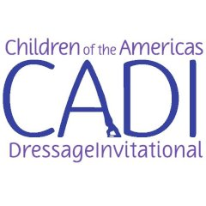
Number:
Rider:
Horse:
Country:

Bear Spot Foundation Musical Freestyle
CHILDRENS
Technical Presentation
 |  | POINTS | COEF. | TOTAL | COMMENTS
1 | Free Walk (20m min.) |  | 2
2 | Medium Walk (20m min.)
3 | Circle Right 10m Working Trot Sitting
4 | Circle Left 10m Working Trot Sitting
5 | Lengthen Stride in Trot Rising |  | 2
6 | Circle Right 15m Working Canter
7 | Circle Left 15m Working Canter
8 | Change of Lead Through Trot Left |  | 2
9 | Change of Lead Through Trot Right |  | 2
10 | Lengthen Stride in Canter
Total possible technical points 140

COMMENTS

Allowed: Counter canter, leg yield
Not allowed: Rein back, shoulder-in, travers, renvers, half-pass, pirouettes, piaffe, passage, flying changes, simple changes

Artistic Presentation
 |  | POINTS | COEF. | TOTAL | COMMENTS
1 | Rhythm, Energy, Elasticity |  | 2
2 | Harmony Between Horse and Rider |  | 2
3 | Choreography, Creativity, Use of Arena |  | 4
4 | Difficulty and Risk |  | 2
5 | Musical Interpretation |  | 4
Total Possible Artistic Points 140
COMMENTS

Total for Technical (divided by 14) | 10
Total for Artistic (divided by 14) | 10
Final  Total artistic points will be used to break ties | 20
Time Limit: 5:00 minutes

Attire: Team polo shirts may be worn in lieu of jackets. Riders may wear team colors and national flag and federation logos. Horses: May have ribbon in manes and tails, body glitter and washable paint. Nothing may obstruct the horse’s eyesight, hearing or movement.

